**Landing, Login, and Enrollment Pages Development**

Benjamin Amrine

The University of Arizona Global Campus

CST 499: Capstone for Computer Software Technology

Dr. Amr Elchouemi

October 17, 2022

**Landing, Login, and Enrollment Pages Development**

To create the university enrollment webpage, I installed the XAMPP Apache application and created a database to store the information using the phpMyAdmin included in the XAMPP. Once these tasks were completed, I used the Apache NetBeans IDE to write the PHP and HTML code necessary to implement the functionalities required. I included bootstrap and javascript for additional cosmetics and responsiveness to the different platforms and screen sizes. Running a PHP file after downloading XAMPP is fairly straightforward;

1. Open the XAMPP control panel

2. Start Apache webserver and MySQL

3. Open any web-browser and type in “localhost/” followed by the file address of the PHP file on the local device. For this project the http://localhost/Cst499Project/index.php is the file that directs the browser to the main landing page. Figure 1 shows the results from navigating to this directory. New users can register using the http://localhost/Cst499Project/registration.php address which prompts new users to fill in some basic required information that will be stored in the database created in MySQL including a hashed password for security purposes. Figure 2 depicts the associated webpage and form for new users. The database was created using the phpMyAdmin IDE and includes an auto-incrementing user identification number, firstname, lastname, and other needed information. Figure 3 shows the table structure for the users database where all information is stored.

The first step in creating a login page that removes the login and register buttons and displays the profile and logout options is providing the user with a way to login. For this example, I have chosen to use the user’s username and password that they created during the registration process. This information was saved to the database and will need to be checked and verified before allowing the user access. In the login.php file, a SELECT statement is used to find the desired information and then additional checks are ran against the selected data comparing it to what was provided from the user ($sql = "SELECT id, username, password FROM users WHERE username = ?";). If all information is correct, the user is then directed to a welcome page displaying the username and additionally changing the login and registration buttons to the profile and logout buttons.

**Figure 1.**

CST 499 Home page

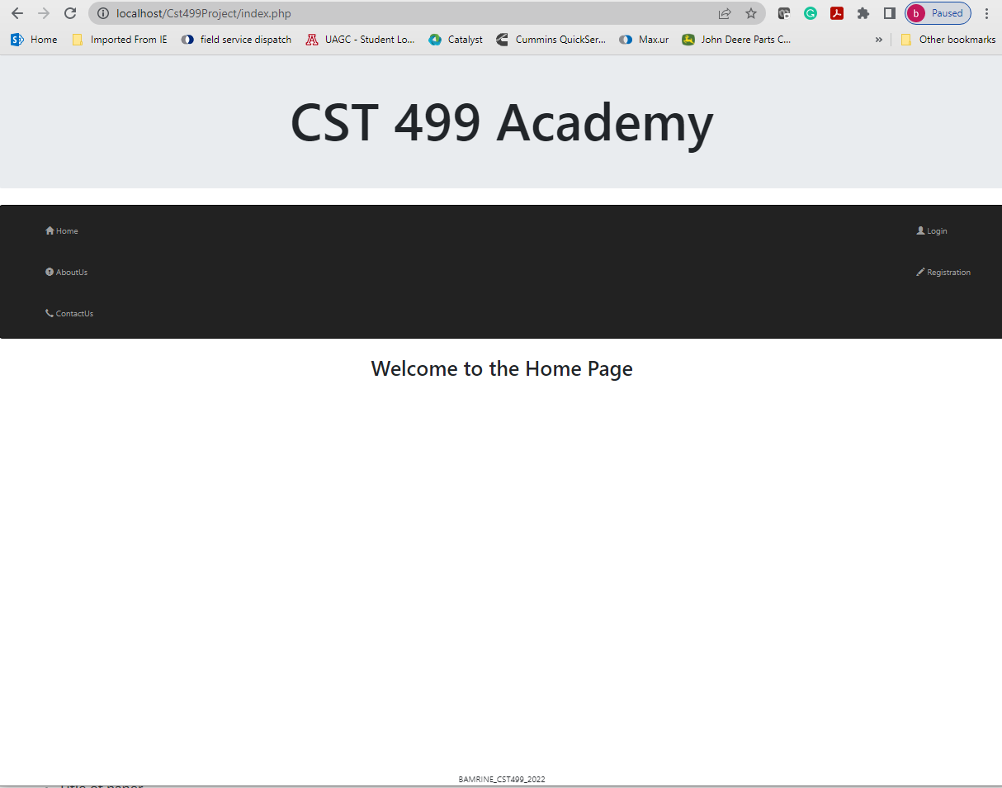

*Note: The photo above shows the results from navigating to the home page via the index.php file in a web browser.*

**Figure 2.**

New Users Registration Page

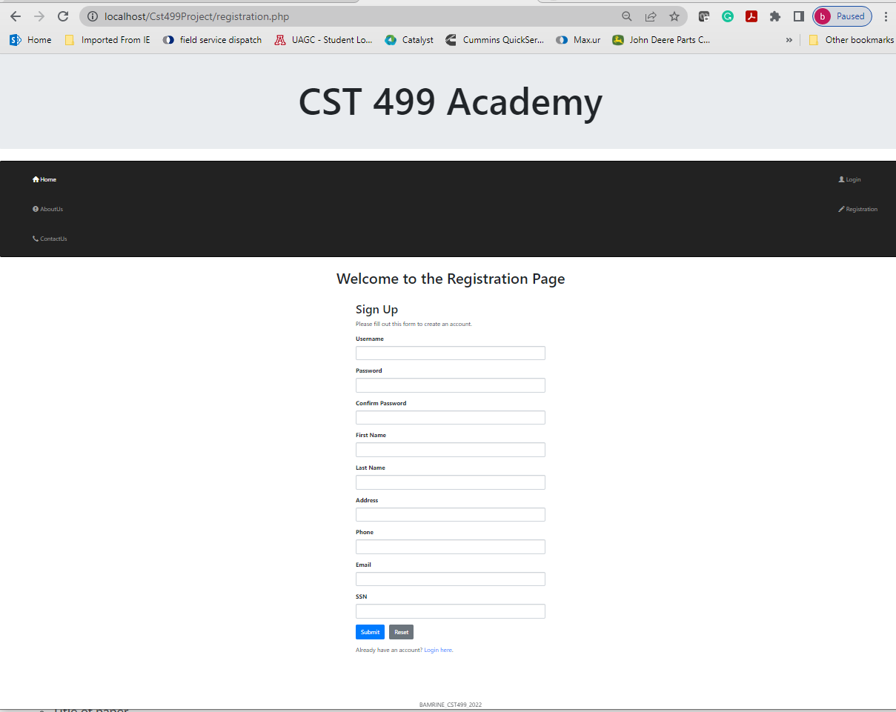

*Note: The figure above shows the layout of the registration page.*

**Figure 3.**

Users database structure

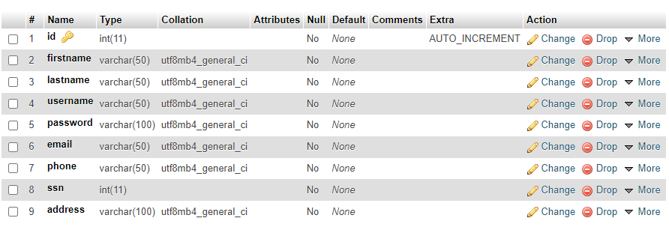

*Note: The above figure shows the structure of the ‘users’ database created for storing all users information.*

**Source Code:**

All source code files can be accessed from the following zip file:

